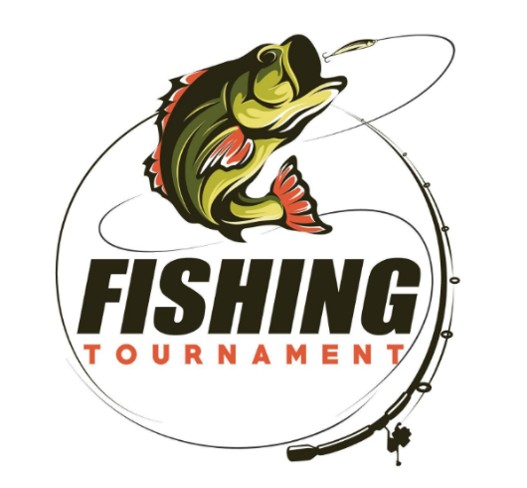

2026 Murray Lake Association Youth Fishing Contest

June 13th
Register on-line via the link below or at the west boat launch between 8:30-9:00am on the day of the event.
Contest to take place between 9:00am and 12:00pm.
Awards and door prizes are to be presented at 12:30pm at the boat launch.
Awards to be presented for the "most" fish and the "largest" fish for the following age groups: 10 and Under
11 to 16
Free to association members and immediate family members. Non- association participants will need to pay a $30 entry fee.
For questions, please contact Charley Schlosser, 616-262-6297.
Per the State of Michigan, this is a "free fishing" weekend. There will be no licenses required.
First ten to register will receive a free gift.
This event will only take place if the weather is permitting. There will be no "make-up" day.
Registration Link Below:
https://docs.google.com/forms/d/e/1FAIpQLSfUbwxgIzBJPB7LSJ9zmIH4BdOEkucYisdTmDgzIYlgzAokdw/viewform?usp=dialog

