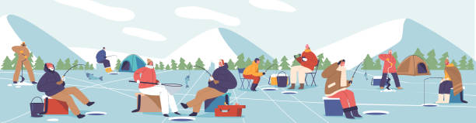

2026 Murray Lake Association Ice Fishing Contest

February 14th
Register on-line via the link below or at the west boat launch between 8:30-9:00.
Contest to take place between 9:00 and 11:30.
Awards and door prizes to be presented at 12:00 at the boat launch.
Awards to be presented for the “most” fish and the “largest” fish for the following age groups:
10 and Under
11 to 15
15+
Raffle tickets will be sold during morning registration on Saturday, February 14th. You must be present at the drawing to win.
Free to association members and immediate family members. Non- association participants will need to pay a $30.00 entry fee.
For questions, please contact Charley Schlosser, 616-262-6297.
Per the State of Michigan, this is a “free fishing” weekend. There will be no licenses required.
The first ten to register will receive a free gift.
https://docs.google.com/forms/d/e/1FAIpQLSfUbwxgIzBJPB7LSJ9zmIH4BdOEkucYisdTmDgzIYlgzAokdw/viewform?usp=publish-editor
The event will only take place if the weather and ice are permitting safe fishing, there is no "make-up" day.

